Name : ibraheem qasim

Sap id : 42896

Section : BSCS 5

**Assignment 1**

**Task 1**

**Code :**

import javax.swing.JFrame;  
import javax.swing.JButton;  
import javax.swing.JRadioButton;  
import javax.swing.JPanel;  
import java.awt.*;  
  
public class Main {  
 public static void main(String[] args) {  
 JFrame frame = new JFrame("window");  
 JPanel panel = new JPanel();  
 frame.setLocation(500, 100);  
 frame.setSize(600, 600);  
 frame.setDefaultCloseOperation(JFrame.*EXIT_ON_CLOSE*);  
 frame.getContentPane().setBackground(Color.*green*);  
 frame.setMinimumSize(new Dimension(600, 600));  
 JButton button = new JButton("Click Me");  
 JRadioButton radioButton = new JRadioButton("Option 1");  
 frame.add(button);  
 //panel.add(button);  
 panel.add(radioButton);  
 frame.setVisible(true);  
  
 }  
}

output :

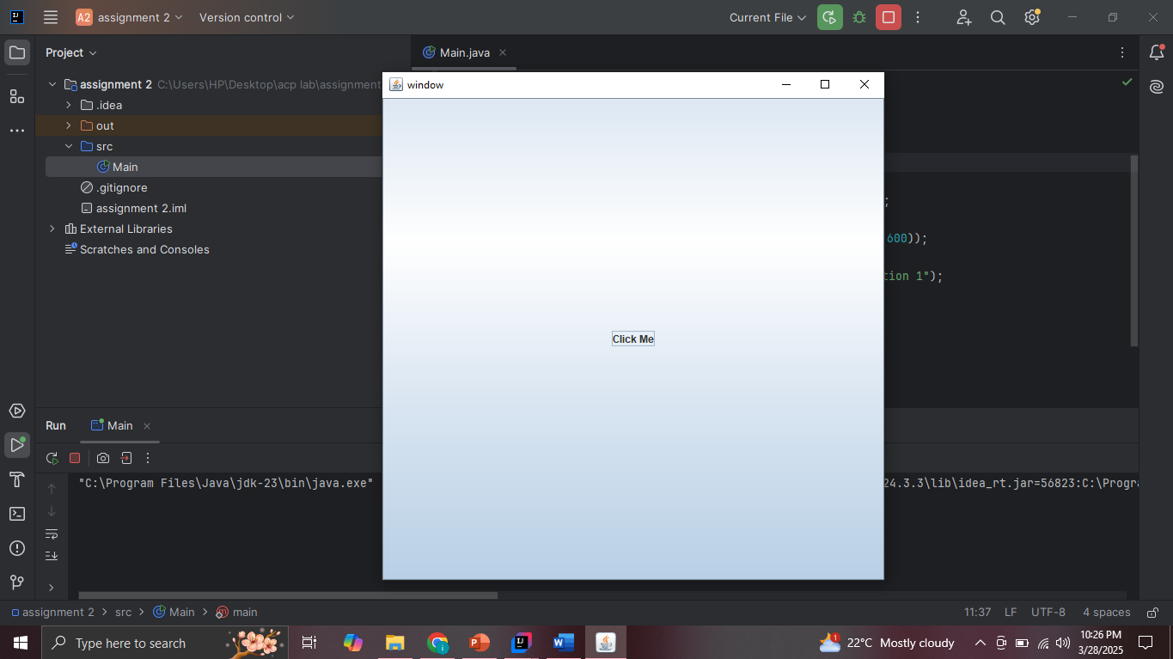

**Task 2 :**

**Code :**

import javax.swing.JFrame;  
import javax.swing.JButton;  
import javax.swing.JLabel;  
import javax.swing.JPanel;  
import java.awt.*;  
  
public class Main {  
 public static void main(String[] args) {  
 JFrame frame = new JFrame("window");  
 JPanel panel = new JPanel();  
 JLabel label = new JLabel("this is task 2");  
 frame.setLocation(500, 100);  
 frame.setSize(600, 600);  
 frame.getContentPane().setBackground(Color.*blue*);  
 frame.setDefaultCloseOperation(JFrame.*EXIT_ON_CLOSE*);  
 panel.add(label);  
  
 for (int i = 1; i <= 6; i++) {  
 JButton button = new JButton("Button " + i);  
 panel.add(button);  
 }  
  
  
 frame.add(panel);  
  
 frame.setVisible(true);  
  
 }  
}

output :

